# Simio API Note: Simio API Helper

May 2018 (Dhouck)

Contents

Simio API Note: Simio API Helper 1

Overview 2

Using The API Helper. 3

Installing the Simio API Helper 5

# Overview

This API Note describes a utility that can be used to examine/test the DLLs that are used by the APIs.

This is a very brief note, as this utility was quickly assembled and being put in place to help a few Simio user debug some API issues.

The intent is that this helper will expand/extend as needed.

# Using The API Helper.

The Simio API Tester is not part of the Simio product. Rather it is simply a test tool that was built to help debug problems.

You can use it to verify that your DLL is:

1. In the right place
2. Is accessible
3. Has the Interface implemented
4. Referencing which other Assemblies

The UI architecture is a simple WinForms tab, and there is currently only one operation tab:

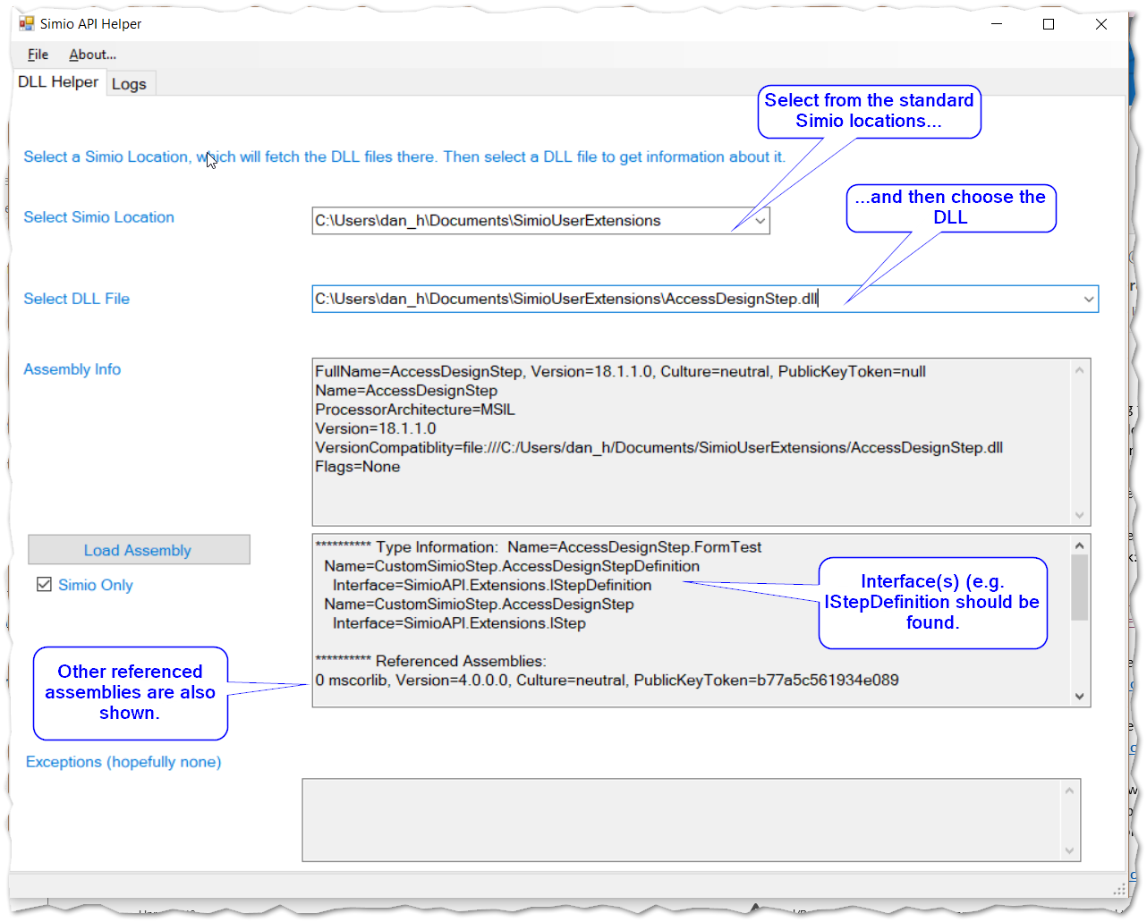

# Installing the Simio API Helper

The helper is just an EXE (SimioApiHelper.exe) and is built with .NET 4.5.2.

There are no other dependencies (e.g. DLLs) beyond .NET.